**ESANSKAR INNOVATION DRIVE PHASE- I**

**Team Name: Plant monitoring robot**

1. **Introduction**

Internet of Things (IoT) is a small electronic device which senses and collects data from around the world and shares this data with backend applications. It communicates with any object, environment, and infrastructure. Nowadays every person is connected with many social media communication networks like Facebook, Whatsapp, Twitter, YouTube, Google+, LinkedIn, Google class, classmates, messenger, Wechat, Qchat, Viber, Snapchat, etc. Communication is a very important part of IoT. The idea of IoT is quite useful for real-world applications and services. A few examples of the application of IoT technology are: Putting on the lights automatically on sensing the human activity, Similarly AC and all other devices need to run in an environment and be switched off based on certain event or trigger. Thus an IoT is basically a framework where the devices are connected to the internet for the purpose of monitoring and control. The First time IoT became popular and made its mark was in the year 1999 when Kevin Ashton applied it for auto-ID. This was a big year for IoT. In 2005 the IoT, combined with ICT technologies, was applied to virtually connect any object at any time and place. IoT applications picked up during 2008 – 2009 with the growth of smart tablet, mobile, PC and other devices connected through the internet. The development of IPv6 helped to reduce the scarcity of public IP address space which was essentially required for the growth of IoT.

**Introduction to Robotics**

1. **What is a robot?**

A robot is an automatically guided machine capable of making decisions required to do a task, by monitoring, navigating through and manipulating its environment.

## History of Robotics

The word Robot is derived from a Czech word Robota’ which means ‘forced labor or a slave’.

## Asimov's Laws

Asimov’s Three Laws of Robotics:

* A robot may not injure a human being or through inaction, allow a human being to come to harm.
* A robot must obey the orders given to it by human beings except where such orders would conflict with the First Law.
* A robot must protect its own existence as long as such protection does not conflict with the First or Second Law.

**Objective**

The aim for this project is to design a Plant monitoring robot which targets the energy saving and autonomous operation on economical affordable for residential and commercial.

Objectives of this project are to:

* Build an energy saving Plant monitoring robot with integrated sensors and controllers
* Design a Plant monitoring robot with modular approach design, which makes the system scalability and expandability.
* Design a Plant monitoring robot which compatibility and scalability with other commercial product and automation system, which might include more than lighting systems.

**Scope**

It’s the technology of today which is touching and transforming every aspect of our real life. IoT has given a concept of Machine to-Machine (M2M) communication. Some of the companies are implementing strategy to capitalize on the Internet of Things so that you can just stop your business and start making it thrives. IoT is going to have huge impact on Plant monitoring robot and building automation system where every convenience will be taken care of by the interconnected devices on IoT. It is also deployed on large scale for example in Song do, South Africa, the first of it sown kind fully equipped and wired smart city is near to completion (known as Ubiquitous City).

**Conclusion**

The Plant monitoring robot using Internet of Things has been experimentally proven to work satisfactorily by connecting simple appliances to it and the appliances were successfully controlled remotely through internet. The designed system not only monitors the sensor data, like temperature, gas, light, motion sensors, but also actuates a process according to the requirement, for example switching on the light when it gets dark. It also stores the sensor parameters in the cloud (Gmail) in a timely manner. This will help the user to analyse the condition of various parameters in the home anytime anywhere.

1. **Problem Definition**

**Understanding the IoT cloud architecture**

The Bolt Cloud is one of the major component in providing the IoT capabilities to the Bolt device. All the Bolt devices connect to the Bolt Cloud out of the box. The Bolt devices are shipped with a firmware that helps it understand how to connect to the Bolt Cloud over the Internet.

**Communication of Bolt Devices with Bolt Cloud**

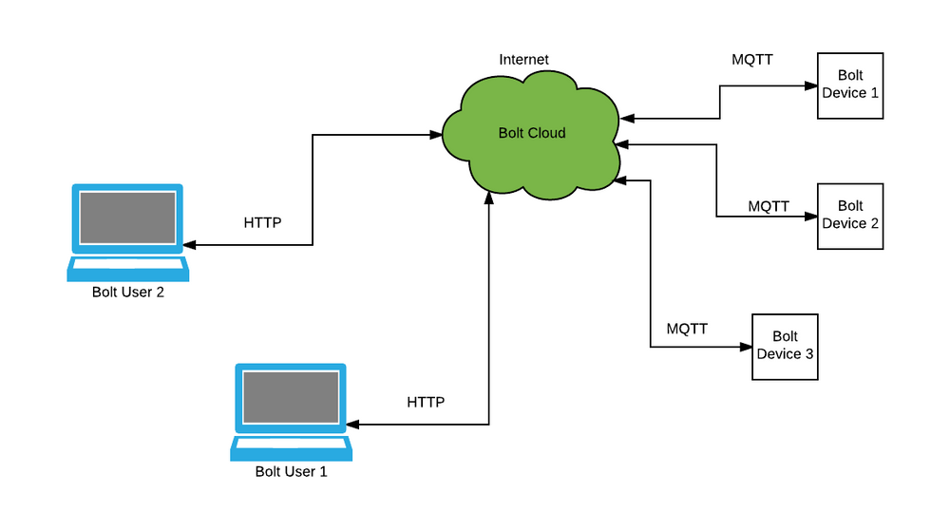

The communication of Bolt devices with Bolt Cloud happens over the MQTT communication protocol. MQTT stands for Message Queue Telemetry Transport. But why do we need to have a protocol such as MQTT for communication when HTTP & HTTPS protocols are so popular and widely used for communication? Although these protocols are popular, the amount of overhead data that is sent over the Internet for managing the communication is quite a lot. Overhead data is the data which is sent along with the actual message/data which conveys the extra information required to understand the message/data sent. The overhead data varies from protocol to protocol. This is fine in case of systems such as mobile phones, laptops, desktop computes that have the hardware capabilities and the network capabilities to send the extra overhead data.

Most IoT devices and sensors contain limited processing capabilities and constrained Internet bandwidth. Due to these limitations, they send data over the Internet only when required and the data sent is very low in terms of bandwidth usage. Hence using protocols such as HTTP, HTTPS does not become feasible where the overhead data is more than the actual data itself. MQTT contains very low overhead and hence becomes ideal for IoT communication.

MQTT is a pub-sub messaging protocol. Pub refers to publishing and sub refers to subscribing. There is a central entity, in our case it is the Bolt Cloud. All the Bolt devices connect to the Bolt Cloud and send the data to various channels by publishing the data on their unique channels. The Bolt devies also subscribe to channels so that they can receive commands coming from the Bolt users.

The Bolt Cloud users i.e. people like us communicate with the Bolt Cloud using the HTTPS communication protocol. We can use the Bolt Cloud dashboard to control and monitor our Bolt devices or use the Bolt Cloud APIs in case we want to by-pass the dashboard and access our Bolt devices via programs that we have written. We shall learn more about this in the next modules.

Bolt Cloud receives all the commands to control or request for sensor data from Bolt devices, and sends the commands to the Bolt device. The Bolt device executes the commands, and sends a response back to the Bolt Cloud which in turn forwards it to the user who initiated the command.

**Problem Statement**

Plant monitoring robot face four main challenges, these are high cost of ownership, inflexibility, poor manageability, and difficulty in achieving security. The main objectives of this project is to design and implement a Plant monitoring robot using IoT that is capable of controlling and automating most of the house appliances through an easy manageable web interface. The proposed system has a great flexibility by using Wi-Fi technology to interconnect its distributed sensors to home automation server. This will decrease the deployment cost and will increase the ability of upgrading, and system reconfiguration.

**What is a plant monitoring robot?**

Well the name plant monitoring robot is a bit of a misnomer. While the name of the robot suggests that the robot monitors plants, what the robot will actually monitor is the environment in which a plant is placed. we learned how logging the light intensity will help us understand how much light a plant is getting. But with 1 Bolt WiFi module you can only monitor this data for one location, and hence we can only monitor the environment of 1 plant.

But what if you had a big garden with lots and lots of plants in it? In such a case you would have to set up a Bolt WiFi module for each location where you wanted to monitor the light intensity. This would be very cumbersome and because you have to have a separate hardware for each location, it would also be expensive. This is where the plant monitoring robot comes to the rescue.

The plant monitoring robot carries with it all the sensors required to monitor the environment, sampling the environment data at different pre-determined locations. It then transmits this data via the Bolt WiFi module to the Bolt Cloud. With this robot you can monitor upto 6 different locations for, light/temperature or any other environment variable.

**Plant monitoring algorithm**

The plant monitoring algorithm is not very difficult to understand, but may sometimes be difficult to implement.

The robot's primary job is to move around the garden, collecting light intensity values. While collecting data using the A0 pin of the Bolt WiFi module was pretty easy, we can't just use the same system here. There are 2 reason for this.

1. There is no way to tell the Bolt WiFi module when a certain location is reached.
2. The data collection is triggered by the Bolt Cloud. This can happen at any time, even when the sensor is not in the right position to collect the data.
3. The A0 pin will only allow you to log data to 1 storage variable in the Bolt Cloud.

**To solve this problem, we have to do the following 3 things.**

1. The data should be collected by the Boltduino, as it will know whether the robot has reached the right location for data collection.
2. The Robot will move in a fixed path moving to different location. We have done this when we built our first robot.
3. The Boltduino will have to take data readings from different locations and store them in local variables. This will allow the Boltduino to send the data to the Bolt WiFi module, even if the Boltduino is not in the right location to collect the data.
4. If the Bolt Cloud asks for data when the robot, is moving from 1 location to another, the robot will have to be able to answer. Since the robot is not able to do anything when the delay function is called, we cannot use the delay function as we used earlier.

**Can you guess how we can make sure that the robot will reach it's destination without using the delay function?**

**To better understand what the Boltduino will have to do, we need to imagine 2 scenarios.**

Imagine a very boring class, where the teacher does not really care if you are paying attention to him or not. In this kind of a class, you know that if you want to sleep you can go to sleep, and the bell for the next class will wake you up. This is similar to how delays work. While the delay is running the boltduino does not change any internal states, allowing the robot to move in the same state as that before the delay.

Imagine another class, where the teacher is strict. She keeps checking if the students are paying attention or not, and sometimes asks students questions out of the blue. Even if you don't like the subject, you have to stay awake throughout the class. You may look at the wall clock for how much time is left before the class ends, but you also have to answer the teachers questions when she asks them. This is the kind of system we will implement for the plant monitoring robot.

The Boltduino has its own internal clock, a lot like the wall clock, which tells the Boltduino exactly how much time has passed since the last time it was reset. We will use this clock to keep track of how far the Botlduino has moved, and accordingly make it move to different locations.

**Problem Statement**

plant monitoring robot face four main challenges, these are high cost of ownership, inflexibility, poor manageability, and difficulty in achieving security. The main objectives of this project is to design and implement a plant monitoring robot using IoT that is capable of controlling and automating most of the house appliances through an easy manageable web interface. The proposed system has a great flexibility by using Wi-Fi technology to interconnect its distributed sensors to home automation server. This will decrease the deployment cost and will increase the ability of upgrading, and system reconfiguration.

1. **Description of Project**

**Chassis Components**

1. Chassis x1
2. Castor wheel x1
3. Set of screws, nuts and spacers x1
4. Motors x2
5. Wheels x2

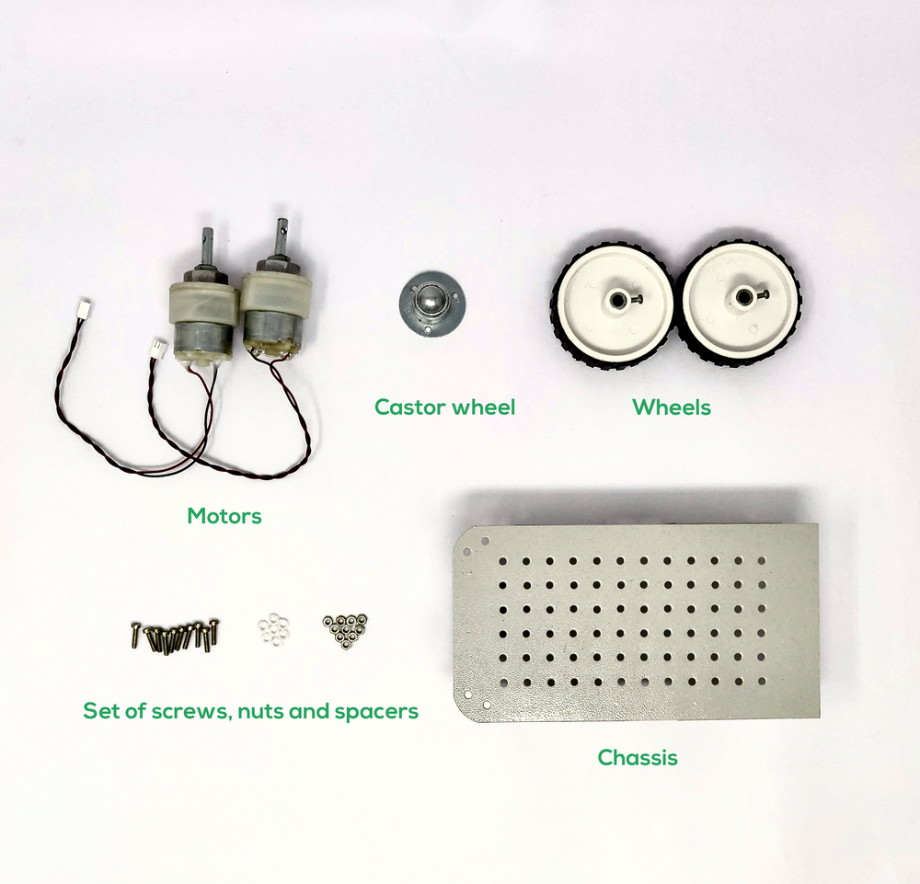

**Circuit Boards**

1. Bolt WiFi module x1
2. Boltduino x1
3. Motor driver shield x1

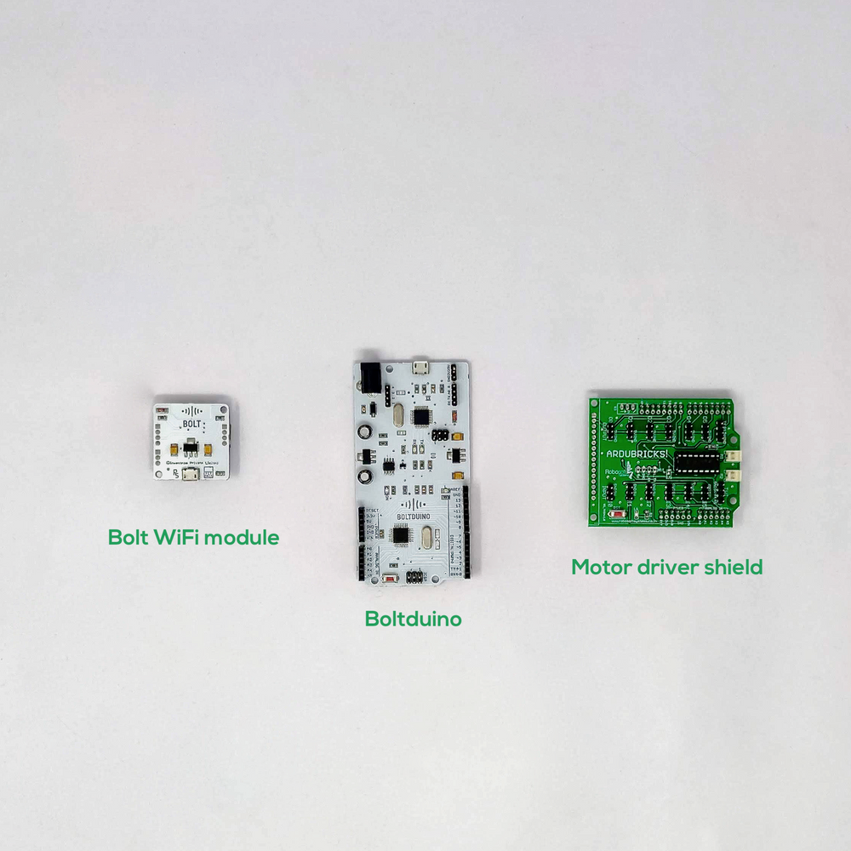

**Small Components**

1. LM35 temp sensor x1
2. 330 ohm resistor x1
3. 10K ohm resistor x1
4. LDR x1
5. Micro switch x1
6. Buzzer x1
7. LED x4

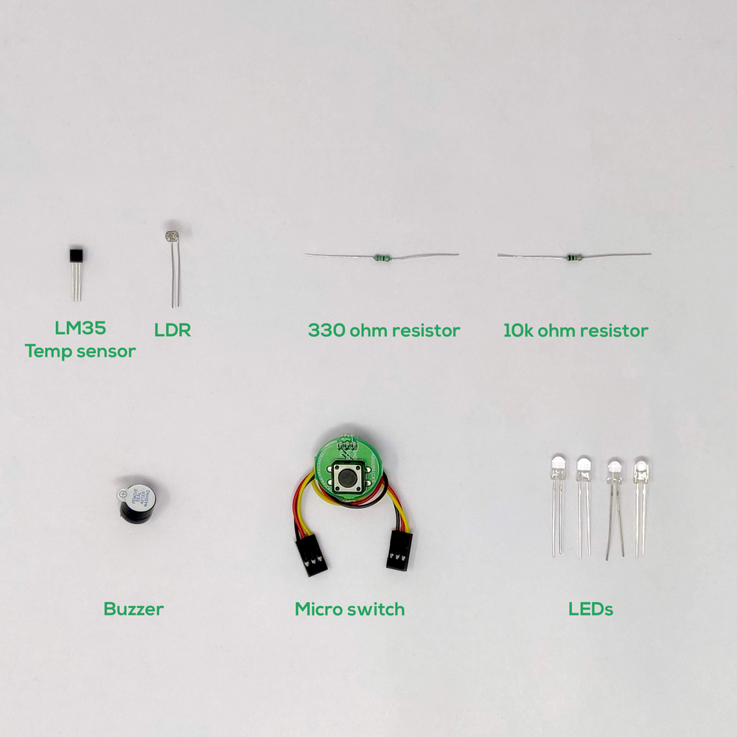

**Large Components**

1. Breadboard x1
2. USB cable x1
3. M to M wires x6
4. M to F wires x3
5. 3-pin F to F wires x4
6. Potentiometer x1
7. 12V Power adapter x1
8. Proximity Sensor x1
9. LDR sensor module x2
10. 10mm LED module x1

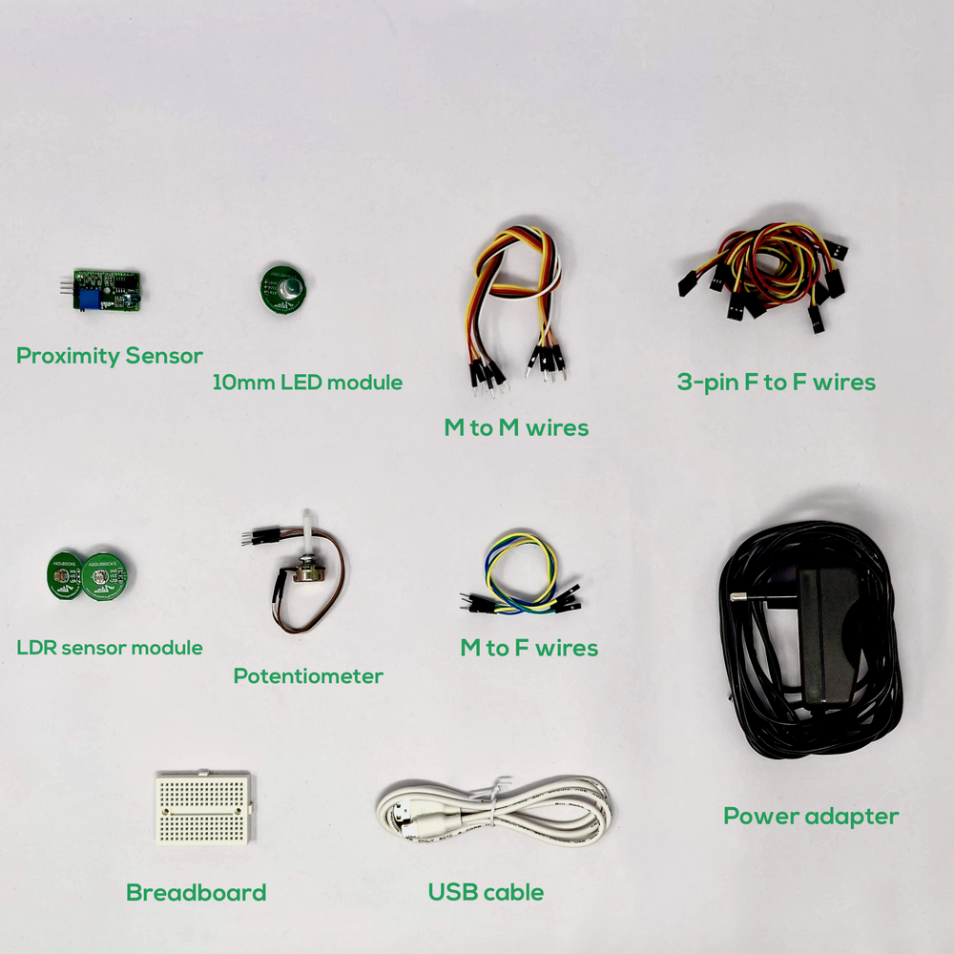

**Tools**

1. Wrench x1
2. Screw Driver x1
3. Double-sided tape x1
4. Insulation tape x1

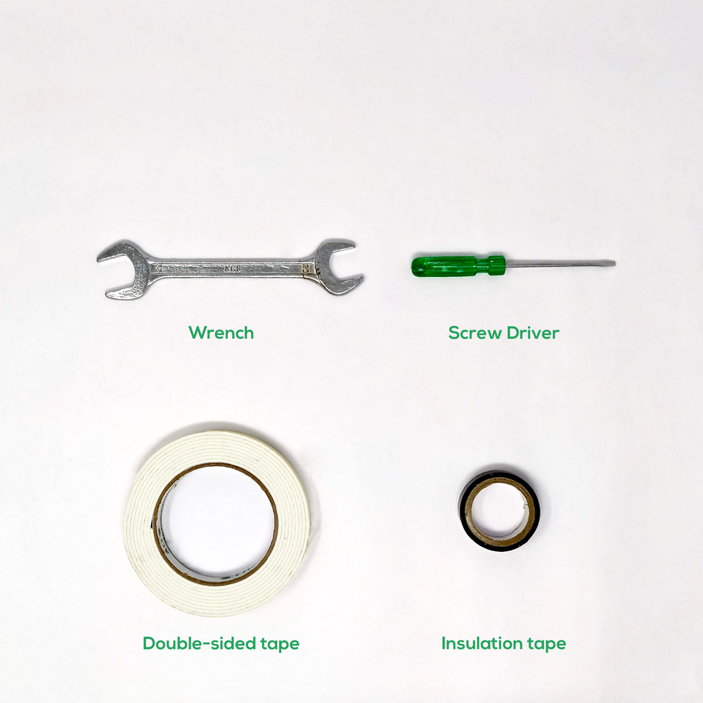

**Creating an account on the IoT cloud service**

Bolt cloud is a server which lets you communicate with your Bolt WiFi module over the internet. It offers features like receiving and storing the data collected by Bolt Modules, Storing the data, Analysing it via Data visualisation and Machine Learning as well as it lets your program your Bolt modules.

**Registration Process**

**Step 1:** Open www.cloud.boltiot.com on your web browser (Google Chrome recommended)

**Step 2:** Click on "SignUp” as shown below

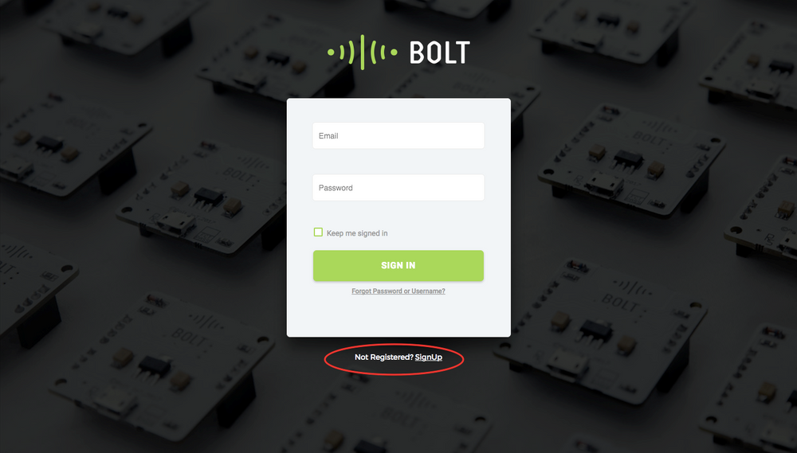

**Step 3:** Enter your details in the SignUp page shown below. Enter your name, email id (login ID for Bolt cloud),and password in the fields. Do confirm your password by typing it again in the Confirm Password field and then click on the Register button.

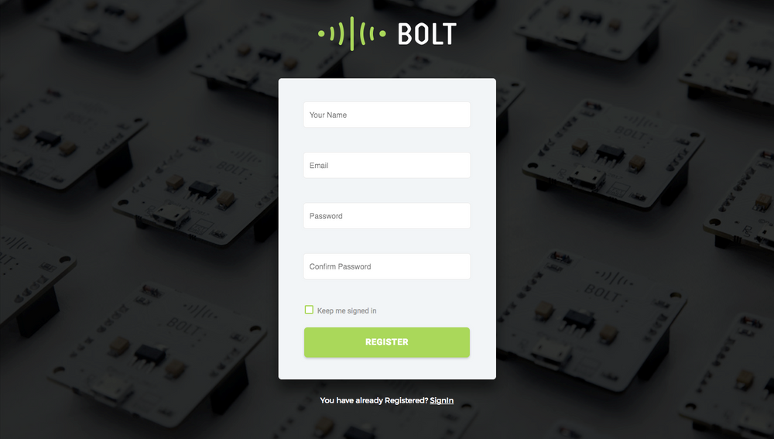

**Step 4:** Verification of your account: If you have entered all the details correctly, you will be successfully registered on Bolt Cloud and you shall see the screen below.

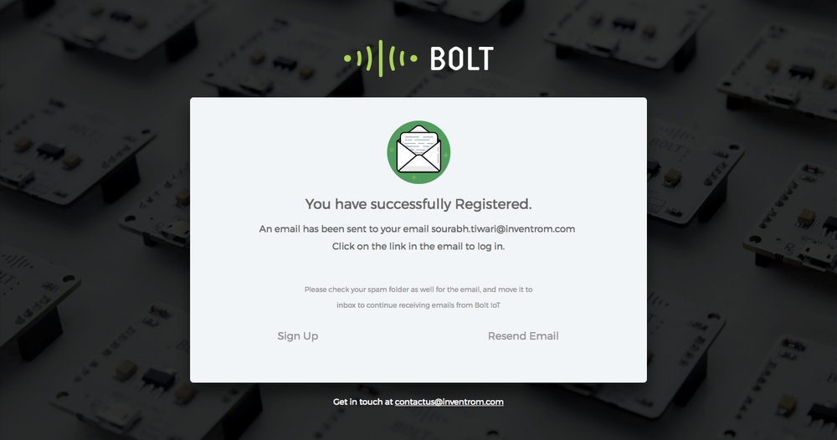

**Step 5:** You will be redirected to your Bolt Cloud Dashboard, with the Welcome message greeting, where you can click on the Getting Started button to view the guide.

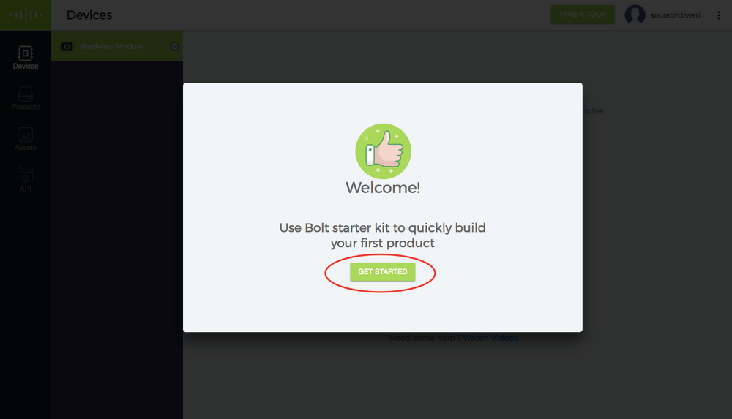

**Step 6:** You will be given a basic tour of the Bolt Cloud features on the Dashboard. You can click on the Next & Back button to view the features. You can click the Skip button to skip the tour if you wish to. The tour can be taken anytime by clicking the “Take a Tour” button at the top right corner on your dashboard.

**Step 7:** Once the tour is done you shall have the option to add a Bolt device to you dashboard. The process of linking your Bolt device to your Cloud Dashboard will be covered in the next lesson.

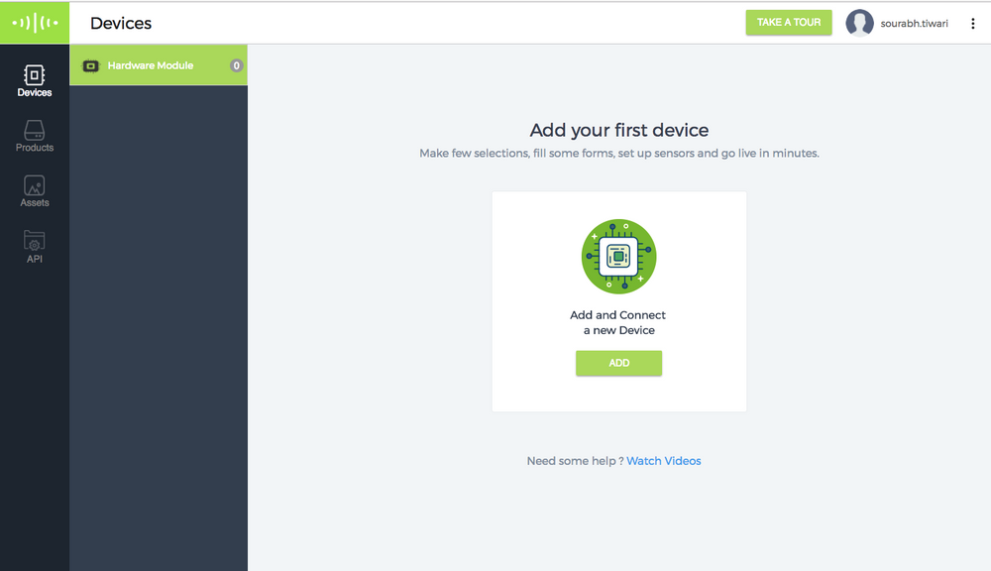

**Installing the Bolt-IoT-Arduino-Helper library.**

Before we can start building the plant monitoring robot, we must first learn how to send data from the Boltduino to the Bolt using UART. Remember we talked about libraries when we talked about robot software? Well to simplify the programming required, to send data from the Boltduino to the Bolt Could, we have developed the BoltIoT-Arduino-Helper library. Use the following steps to install the library into your Arduino IDE.

**Step 1]** Click [here](https://drive.google.com/file/d/1mT4uzG0D9LUAEhhHS_KvbMQ5HftnFaQ6/view) to go to the download page for the BoltIoT-Arduino-Helper library.

**Step 2]** Click on the download button in the page to download the library file.

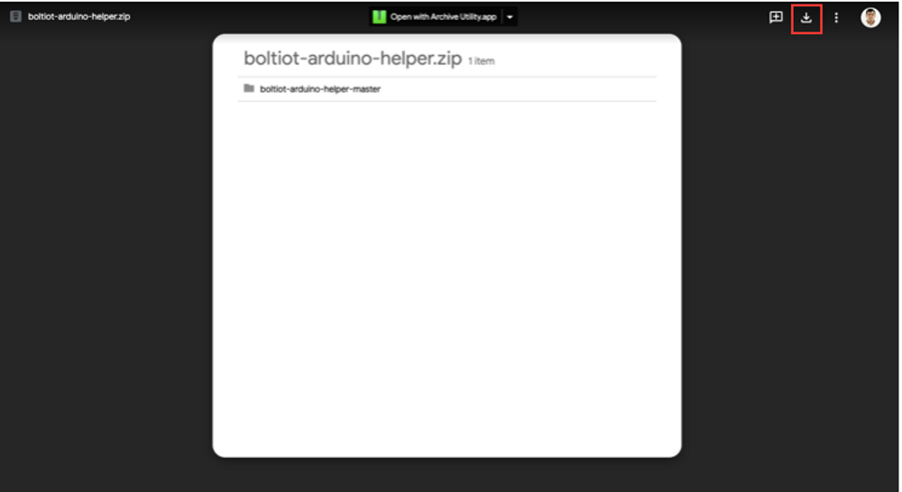

**Step 3]** Wait for the zip file to be downloaded

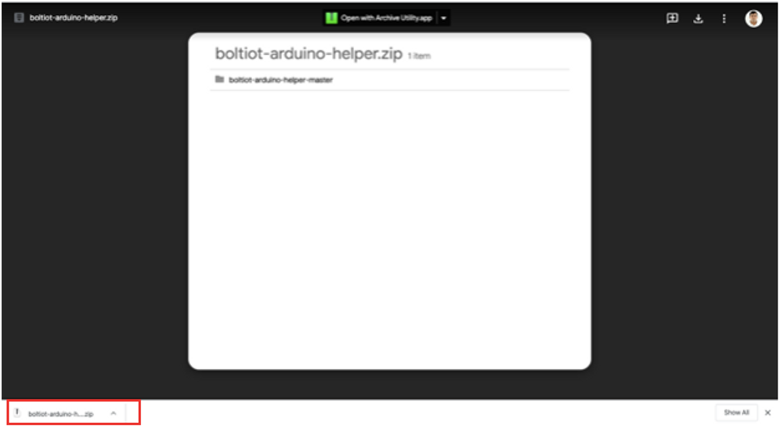

**Step 4]** In the Arduino IDE to go sketch>import library> add .zip file.

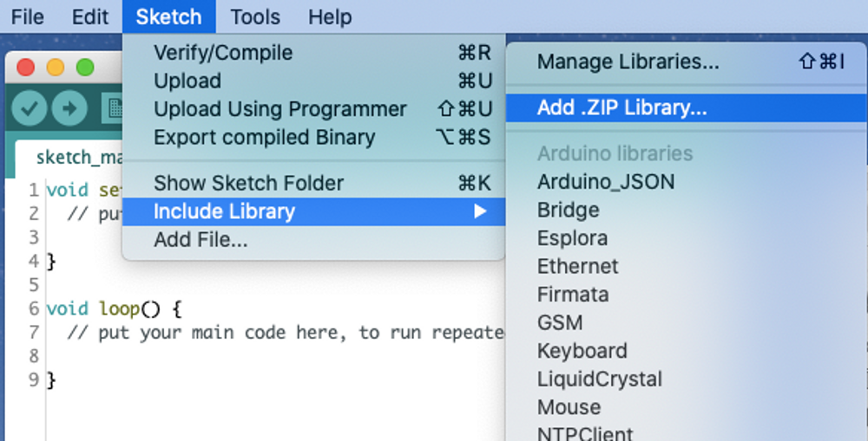

**Step 5]** Go to your downloads folder, select the file "boltiot-arduino-helper" that you just downloaded and click on choose.

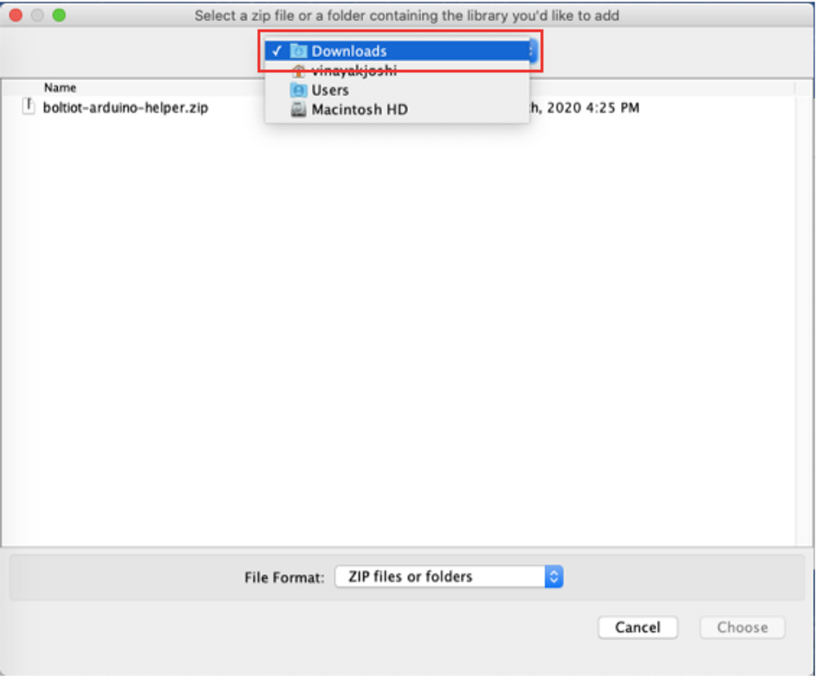

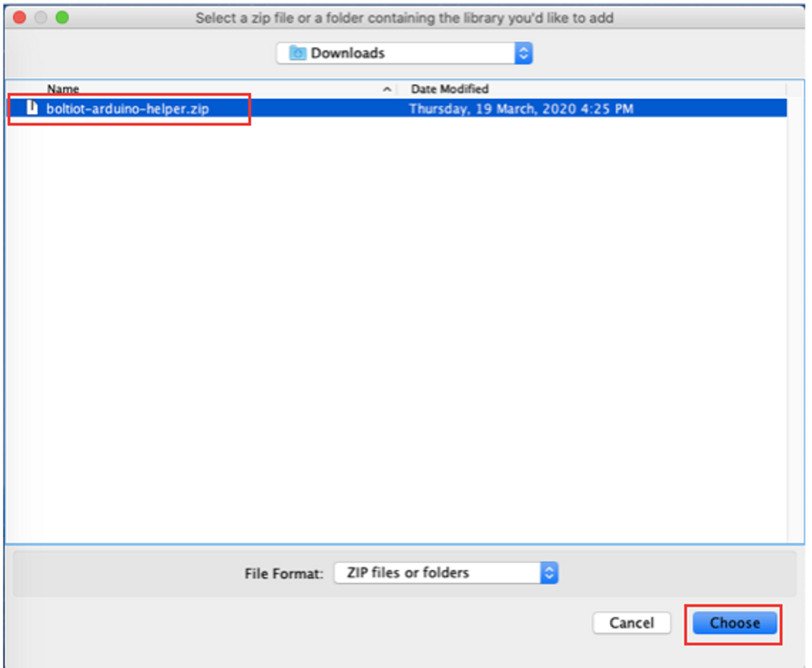

**Step 6]** Wait for the library to be installed. The Arduino IDE will display this message once it is done installing the library.

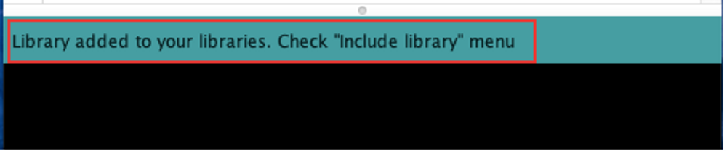

**Well that's it. The library is installed. Simple is it not? Now that we have the library installed, let's look at testing the installed library.**

**Rounding up the components**

**To build the Plant Monitoring robot, you will need the following components.**

1. **The robot that you had assembled earlier.**

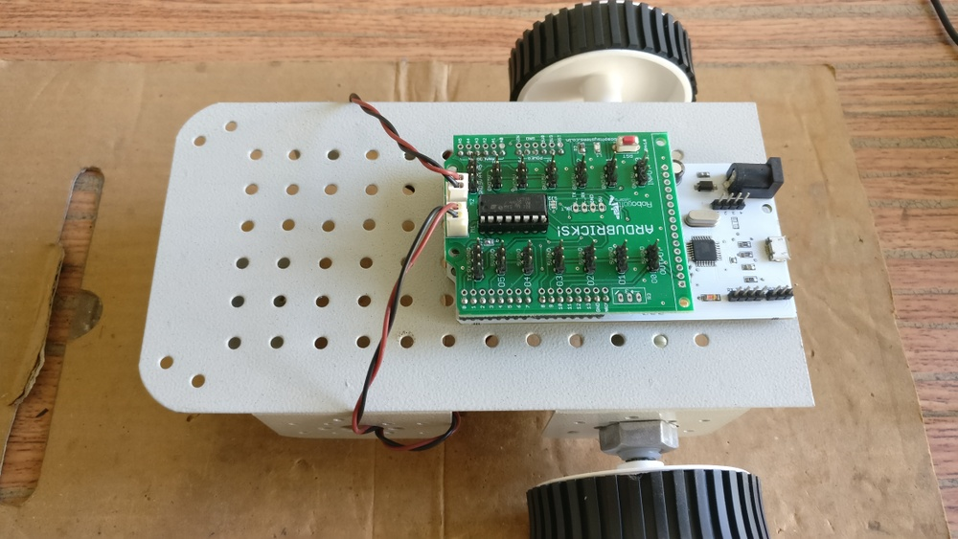

1. **1 Light sensor modules.**

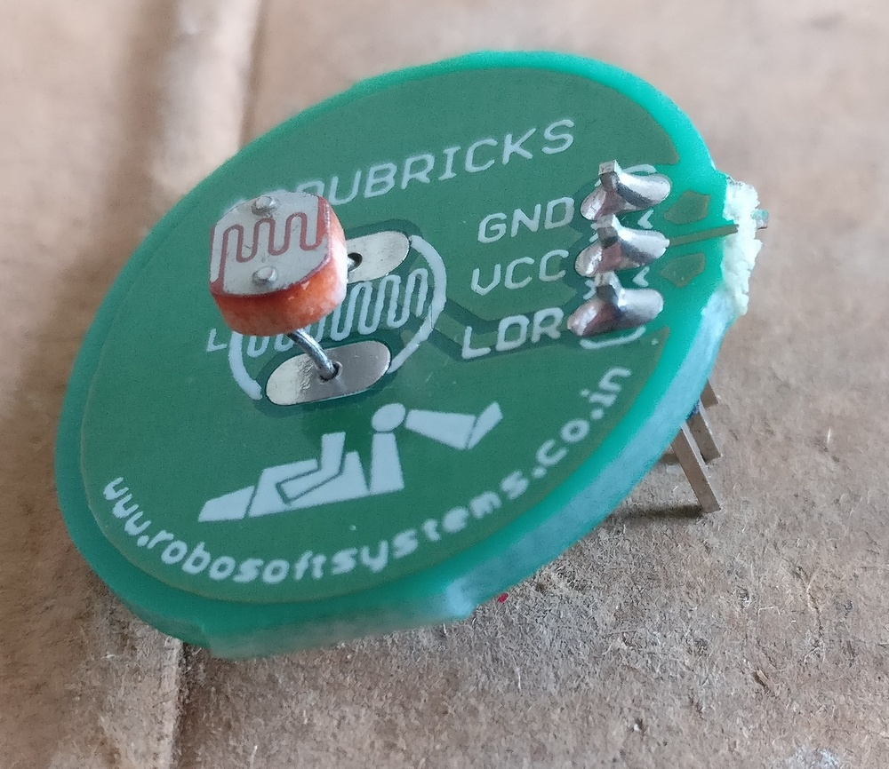

1. **1x 3 pin female to female berge pin connector**

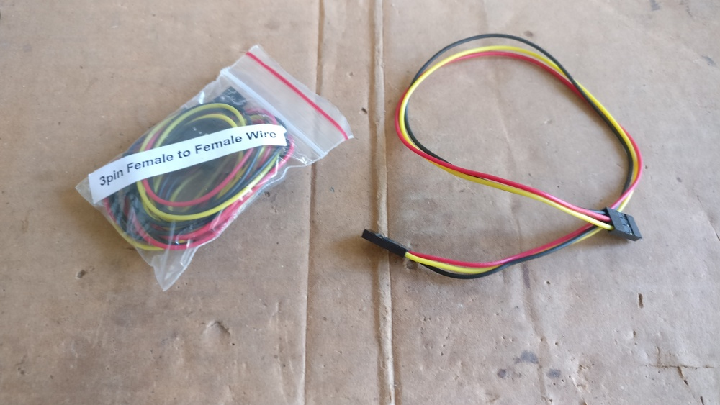

1. **DC power supply.**

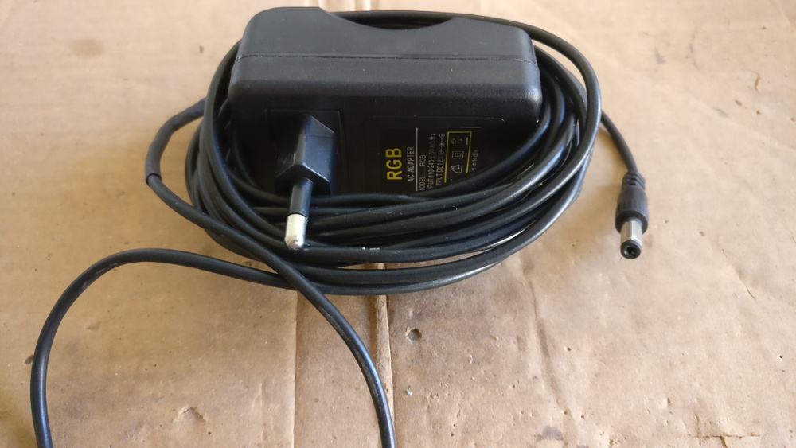

1. **Micro USB cable**

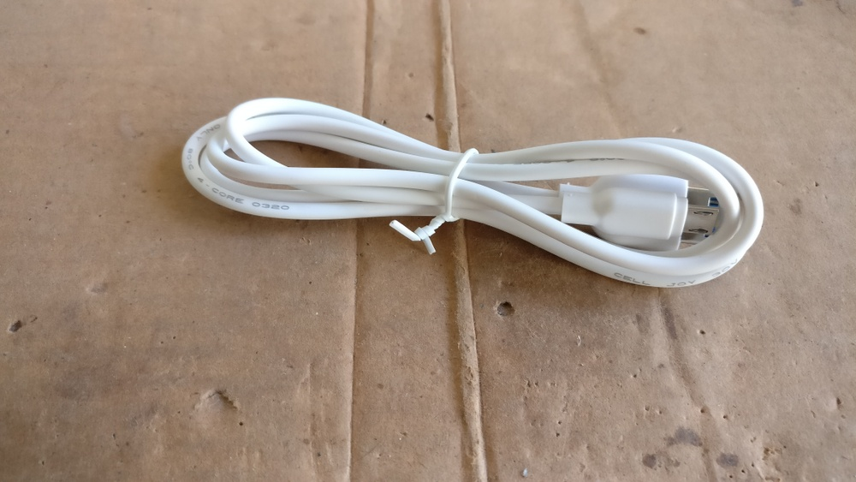

1. **The Bolt WiFi module**

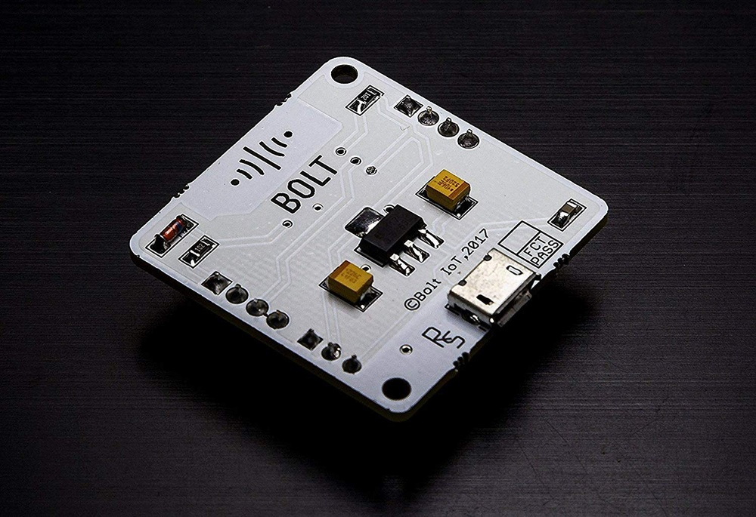

**You will also need the following tools**

1. **Double sided tape**

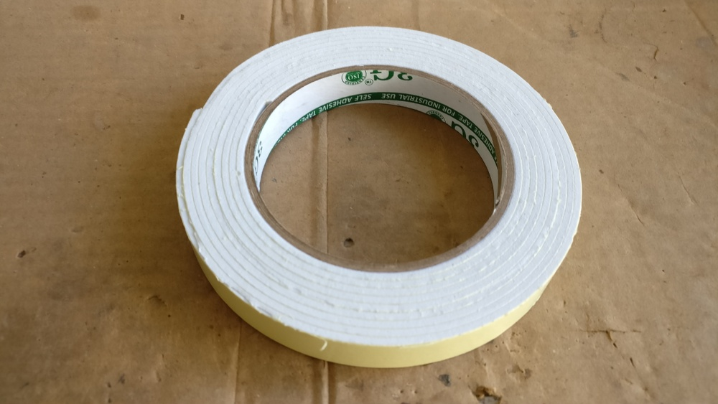

1. **Mechanical components box to place the robot on.**

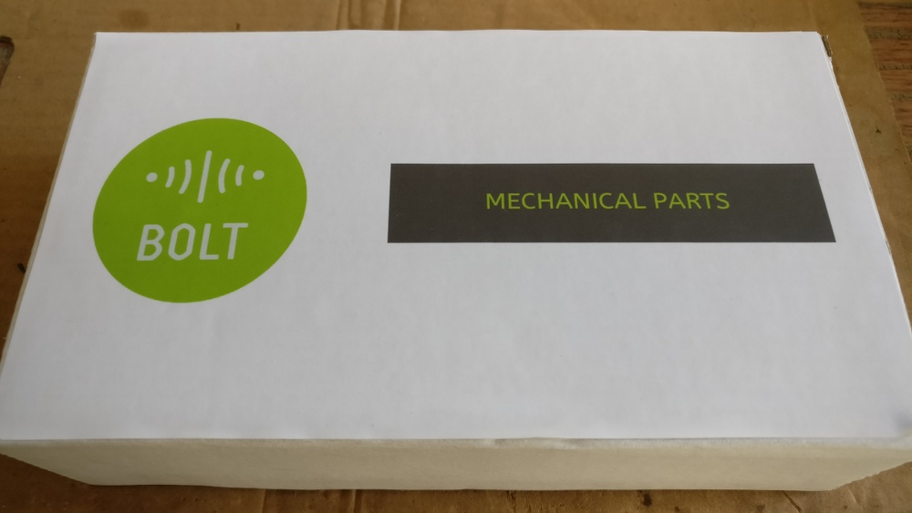

**Assembling the components**

**Now that we have all the components required to build a plant monitoring robot, let's look at how to assemble the robot.**

Cut out 1 small piece of the double-sided tape and stick it to the lower side of the light sensors sensor.

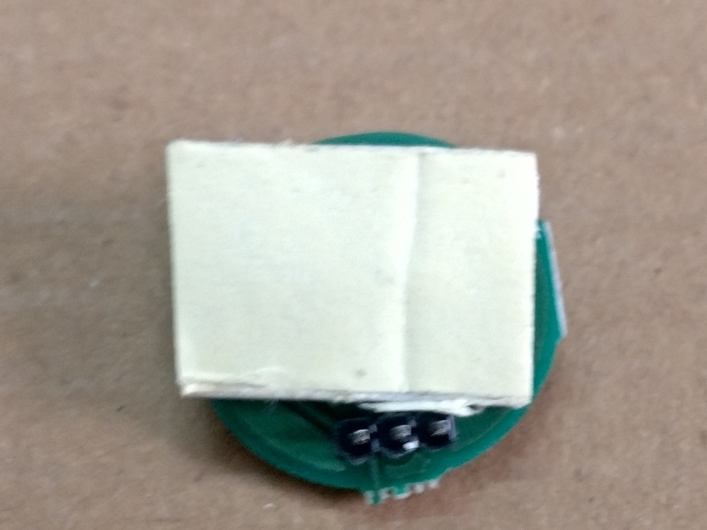

Remove the coating of the double-sided tape on the sensor.

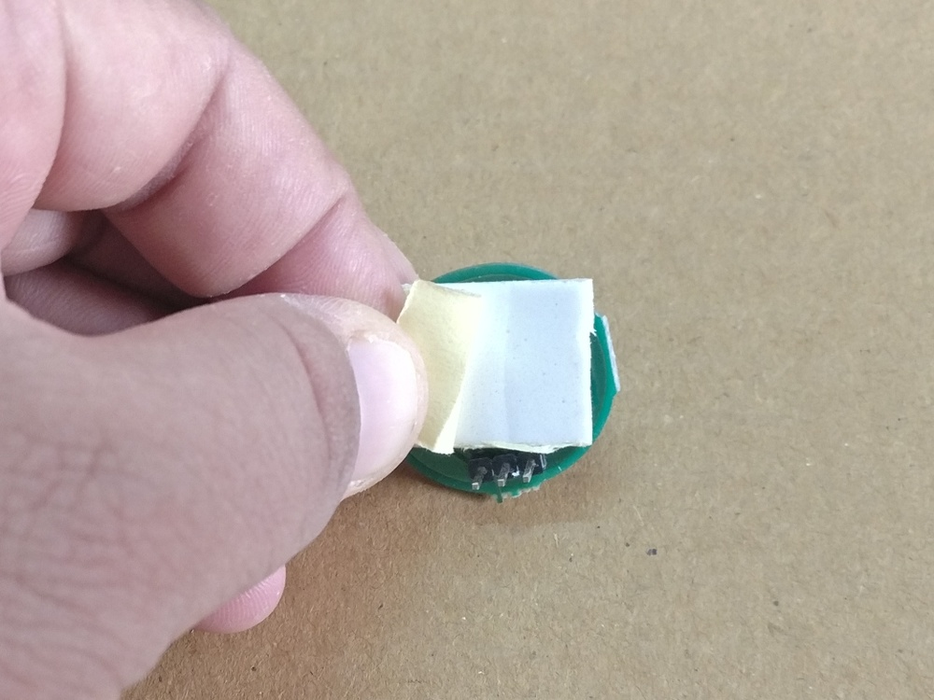

Next place the pre-assembled robot on the white mechanical components box.

Stick the light sensor at the front of the Robot making sure that the sensor is facing the sealing and the pins of the sensor are pointing to the ground

**NOTE: Ensure that the pins of the sensor DO NOT touch the robot chassis.**

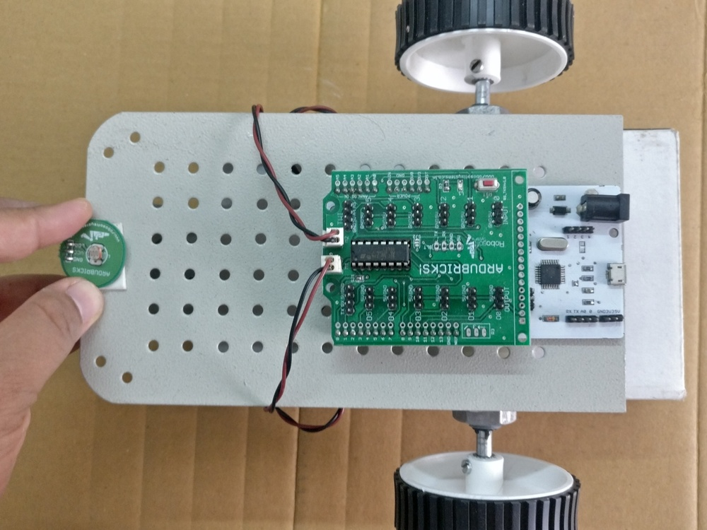

Next connect each of the 3 pin berge pin connector to the sensor. Look at the photo below, and ensure tha the yellow wire is connected to the LDR pin, the red wire to the VCC pin and the black wire to the GND pin.

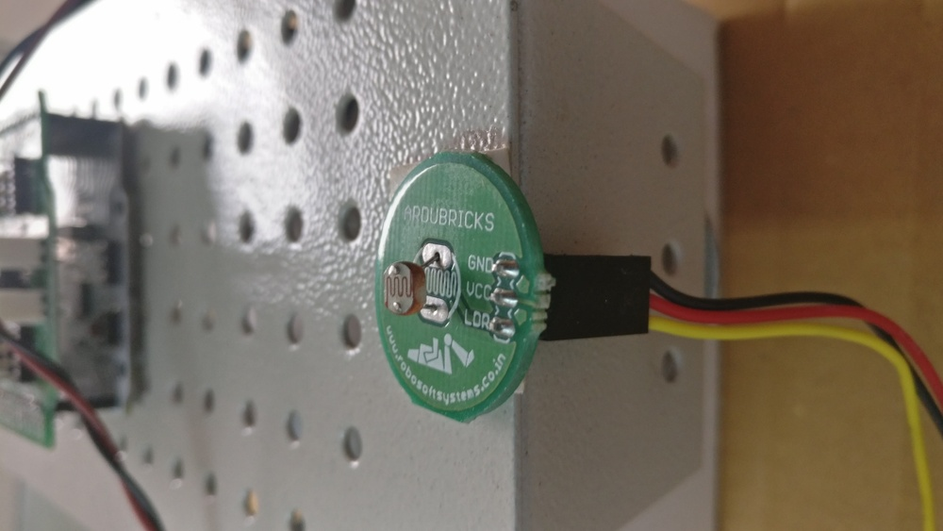

**Now connect the other ends of the 3 pin berge connector to the motor driver shield on port number I0 as shown in the photo below.**

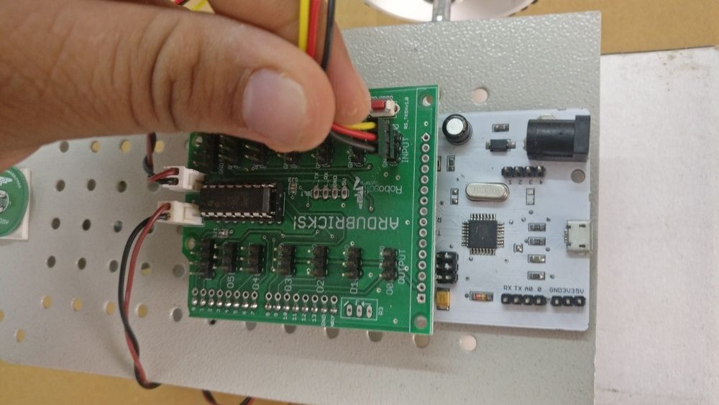

Once this step is done, your robot will look similar to the photo below.

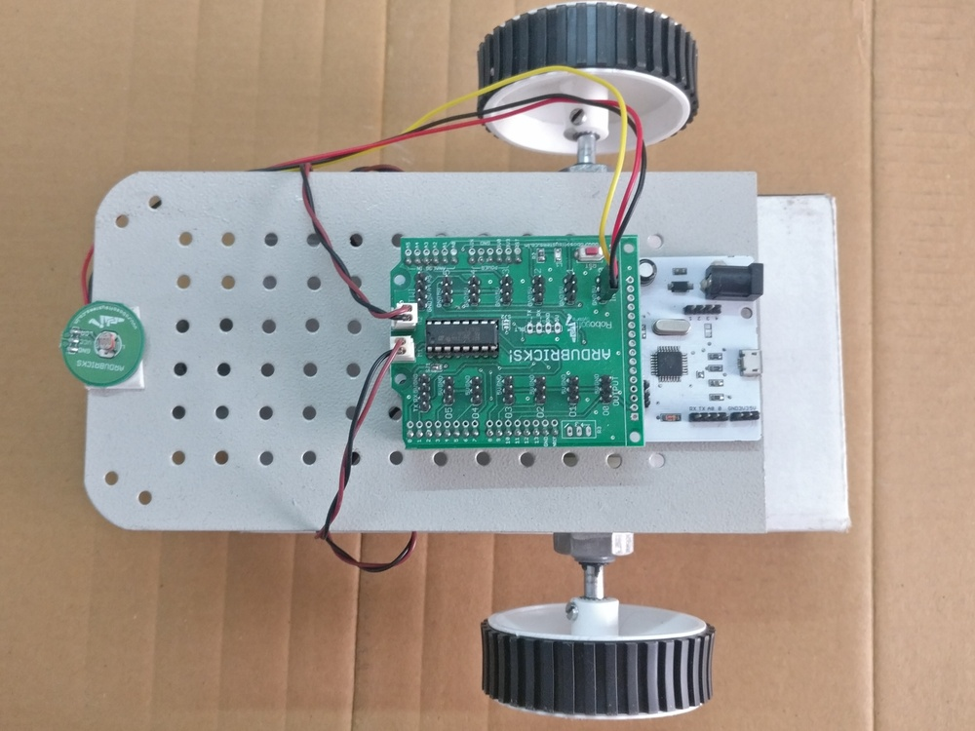

We will be mounting the Bolt WiFi module once we finish programming the Boltduino. We do this in order to make sure that the Bolt WiFi module does not interfere with the program uploading process.

You can now connect the robot to the computer using the mico-usb cable.

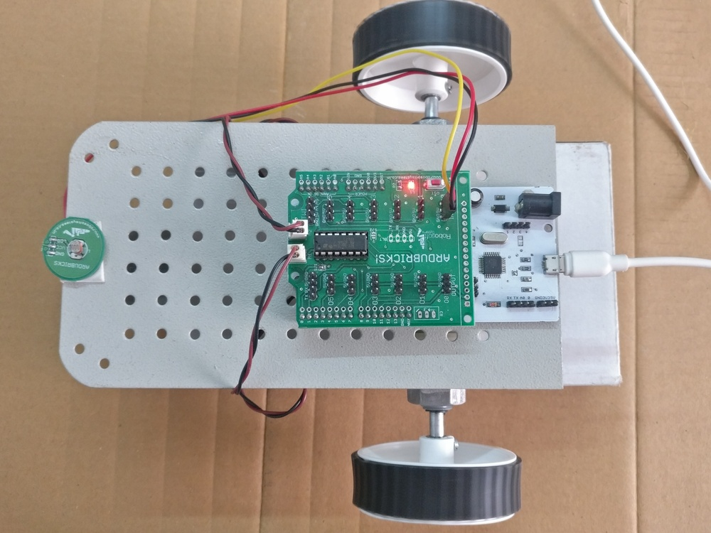

Now that we have finished assembling the robot, let's have a quick look at the algorithm that we will use to make sure that the robot follows any visible light source.

**Coding the robot**

To code this robot, we will first have to tell the Botlduino to use the BoltIoT-Arduino-Helper library that we installed in the previous chapter. This can be done using the instruction "#include" followed by the name of the "header" file which defines the function we need from the library.

**Step 1] Create a new Arduino sketch by selecting File>New**

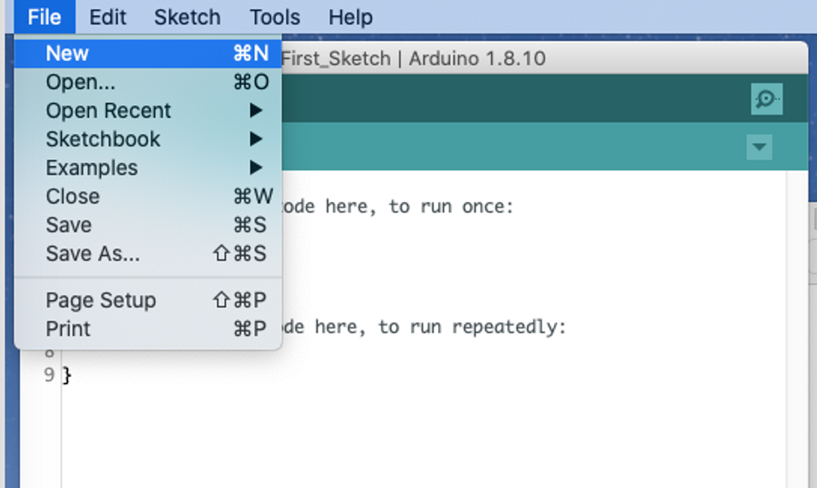

**Step 2] Write the above into the sketch as shown below.**

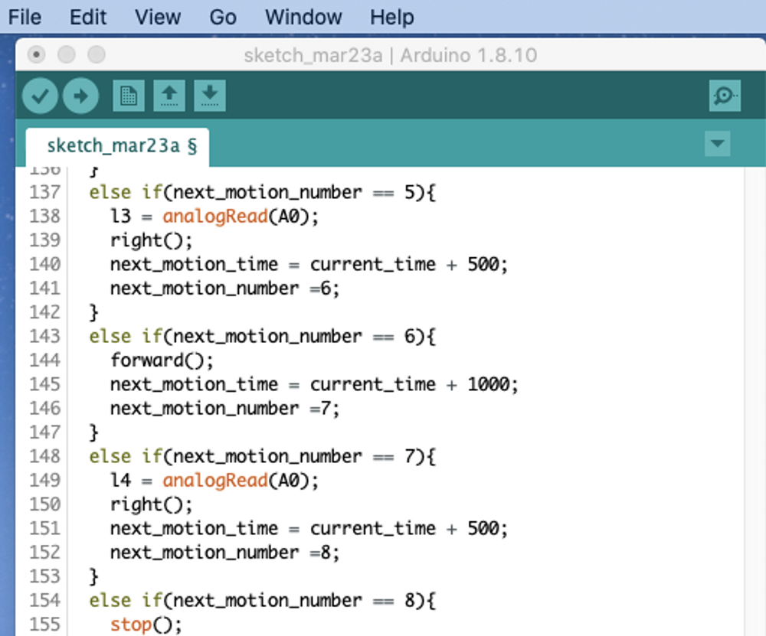

**Step 3] Save the code by selecting File>Save, and give it an appropriate name and save the sketch.**

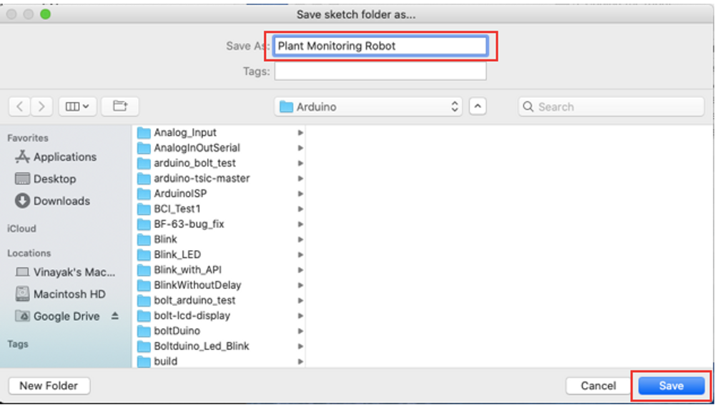

**Step 4] Upload the code to the Boltduino.**

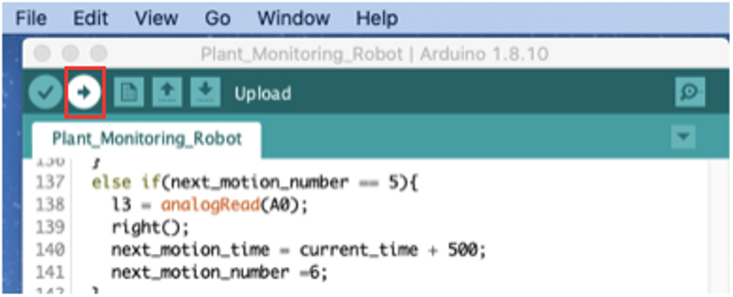

**Step 5] Wait for the Arduino IDE to compile the sketch and upload the code to the Boltduino.**

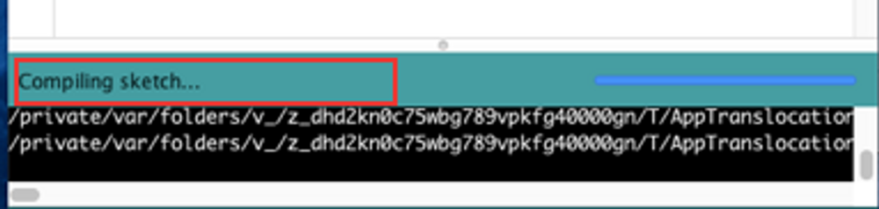

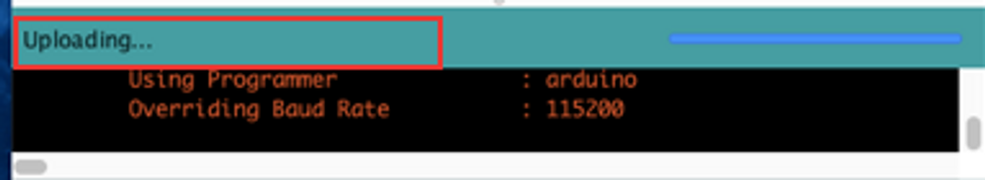

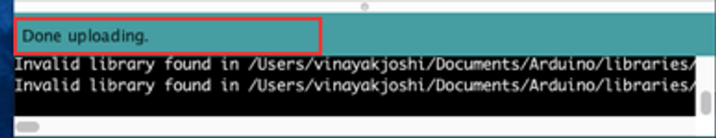

**Configuring a UART product**

We may have finished building and coding the robot, but a plant monitoring robot is not complete without it's cloud dashboard where you can see the readings being logged.

Let's configure a Bolt Cloud product to collect this data from the Boltduino and log it to the Bolt Cloud.

**Step 1]** Go to the products tab in the Bolt Cloud dashboard (click [here](https://cloud.boltiot.com/login?next=%2Fhome%2F%3Fp_name%3Dnone)), and create a new product.

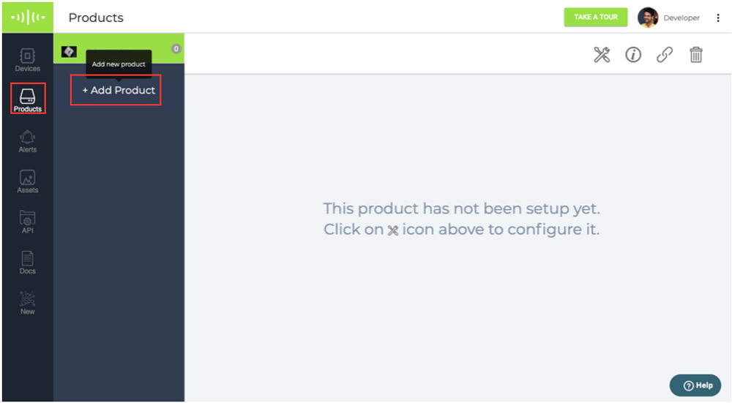

**Step 2]** While creating a new product select input and UART. Add "plant_monitor" as a product name and click on done.

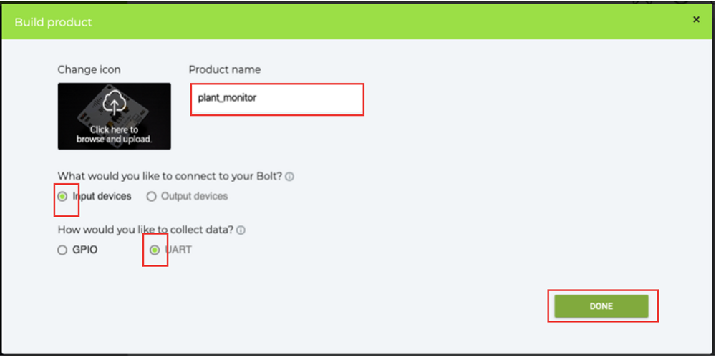

**Step 3]** Select the newly created product and click on the configure button.

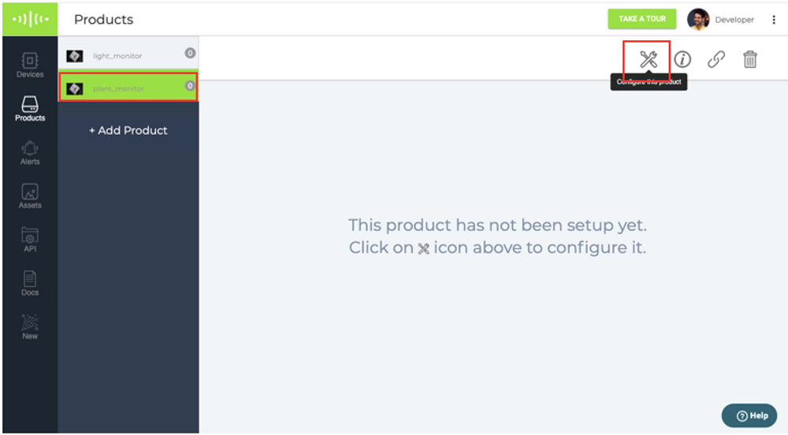

**Step 4]** The hardware configuration screen will ask you how many data points you want to log as "CSV" or comma separated values. Since we will be logging 4 values, select 4 in this drop down menu.

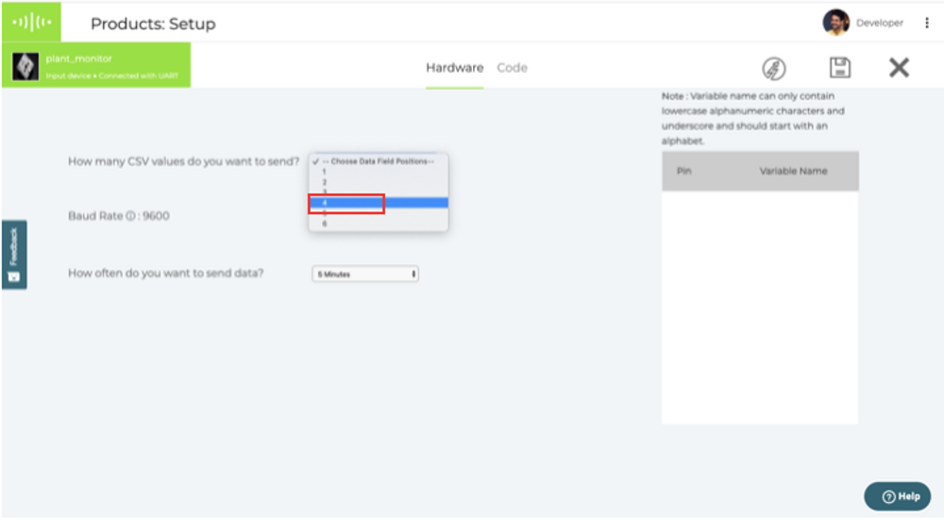

**Step 5]** Give appropriate names for these variables. In the image we have used light1, light2, light3 and light4. Click on the same configuration button.

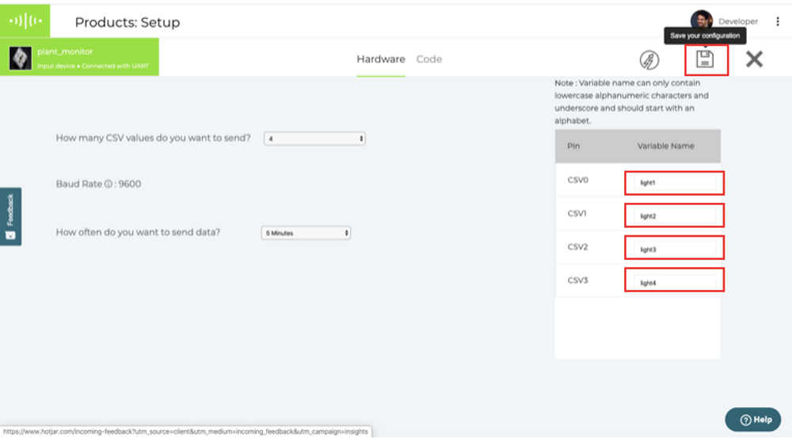

**Step 6]** Go to the code configuration tab.

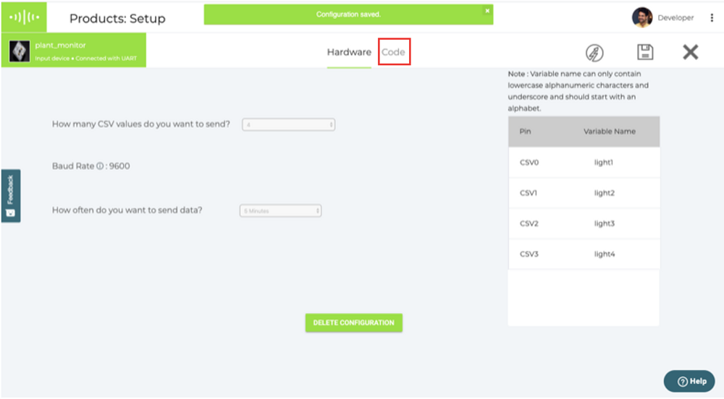

**Step 7]** Enter a suitable name for the code file which will be saved. In the image below we have used "plant_monitor". Select file type as JS,

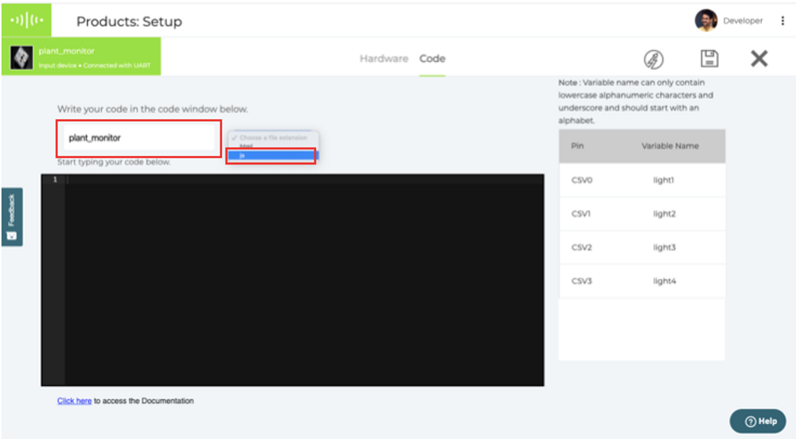

We will now write the code required to display the logged data values. The last time we configured a product we only had 1 data point to log. Since this time we have 4 values to be plotted, we will have to use a different set of instructions to plot the graphs. This code will be written in javascript, and the syntax is a bit different from C++.

We must first initialise a variable which will help us draw a graph. This is done using the "new boltGraph()" function, and store the object created in a variable named "graphObj". Variables in javascript are declared using the "var" identifier. This instruction will be the first line of our code.

We will then call the plotChart function, via our grapObj variable. Using the plotChart function this way allows you to pass as many variables as you want to be displayed in the table view.

We want to be able to see all 4 light values, along with the time at which the values were logged. As such we will pass 5 arguments to the function. Starting with "time_stamp", followed by the 4 variable names that we declared in the hardware configuration.

**Step 8]** Add the above code to the coding window, and click the "Save Your Configuration" button followed by the "Exit" button.

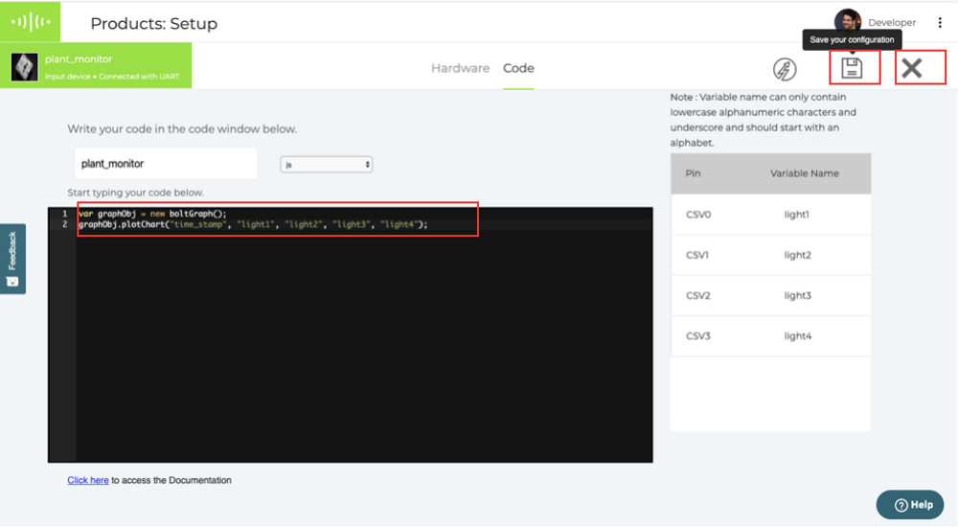

**Step 9]** At this step, your UART product is configured. The next step is to link your Bolt WiFi module, and to this product. To do this, click on the link button in the products tab.

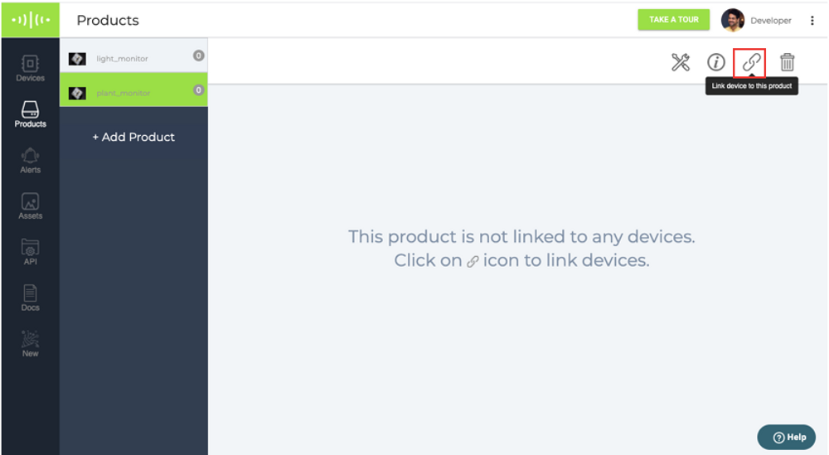

**Step 10]** Select your Bolt WiFi module and click on the link button.

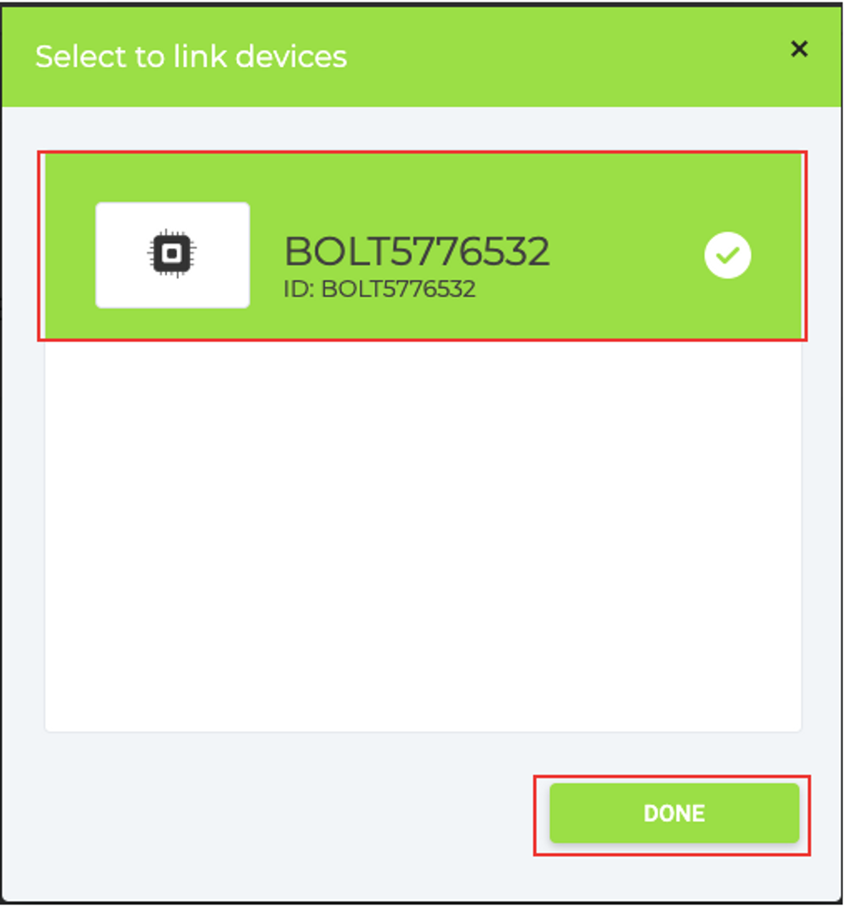

**Step 11]** Connect the Bolt WiFi module to the plant monitoring robot.

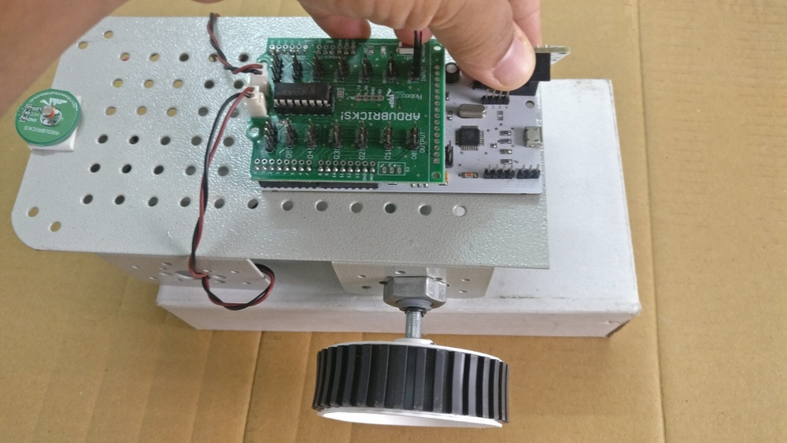

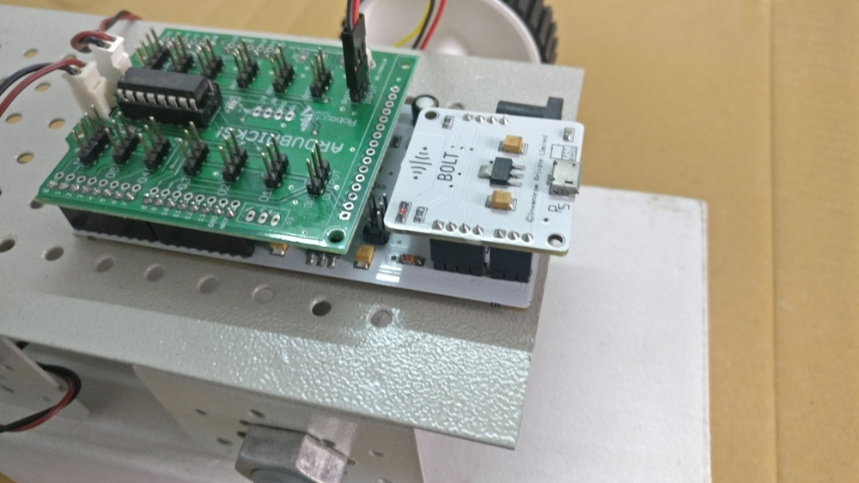

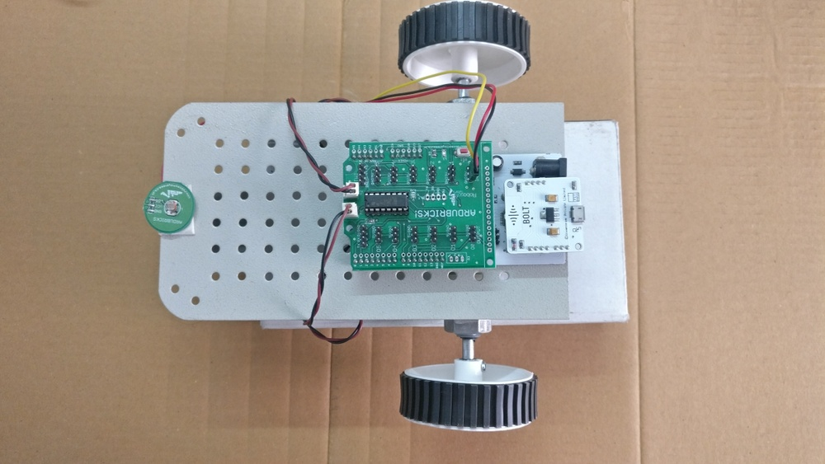

**Step 12]** Place the robot on the floor, power up the robot. The robot will start moving immediately, but the Bolt WiFi module will take some time to come online. Wait for the Bolt WiFi module to come online.

**Step 13]** Click on the device view button to see the data being collected by the robot.

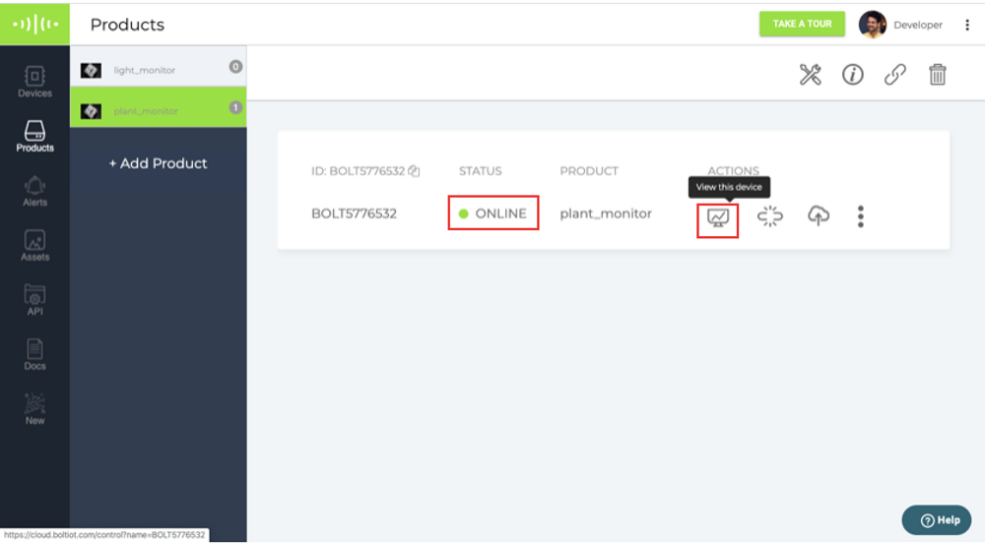

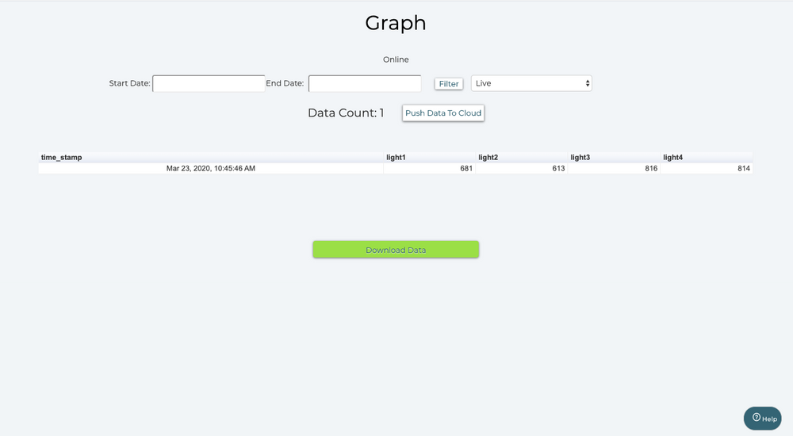

You can then wait for about an hour for the robot to collect upto 12 readings. While the robot is doing that, change the lighting conditions at the corner location to check whether changes in the lighting conditions get reflected in the data collected online. You can use a flashlight or something of the sort.

Well that it! You now have a plant monitoring robot.

1. **Advantages, Disadvantages & Applications**

**Advantages:**

1. Using this project, you will be able to build a light monitoring system to collect the data and send it to the cloud.
2. You will also learn to visualise the data in form of graphs.
3. This project can then be extended to Predict the future sensor values via machine learning over the Bolt Cloud.
4. You may also send alerts over SMS and email using the features of Bolt Cloud Pro.

**Disadvantages:**

1. We have to buy hardware kit.
2. You have to keep checking result every 5 min.
3. You need Good internet connectivity.

**Applications:**

This project is based on the principle that whenever the light falling on the sensor changes, the resistance of sensor changes which is then converted into a change in voltage. The ADC pin on Bolt WiFi Module converted this analog voltage level into digital values which are shown on the graphs.

We connect the LDR between 5v pin and the analog input pin (A0), so that when light intensity increases, the resistance of LDR decreases so the voltage across the LDR decreases and as a result, the voltage on the analog input pin increases.

This means that as the light intensity increases, the voltage on the analog input pin also increases. The Bolt then converts that the voltage a 10 bit (10 places in binary number system) digital value that varies from 0-1024 (0 to 2 raised to 10).

This digital data is then sent to the cloud where it is plotted for visual representation.

**Project Link :** [Click Here](https://drive.google.com/file/d/1JKPnMPu6c6BJ--dK8oyBL-LB0zzfdbxr/view?usp=sharing)